SAVEETHA SCHOOL OF ENGINEERING

DSA0402 – FUNDAMENTALS OF DATA SCIENCE
IET ASSIGNMENT DSA0402

BANK CUSTOMER SUBSCRIPTION PREDICTION
AND CUSTOMER SEGMENTATION SYSTEM

Submitted by
E.C. Jithendra Kumar Reddy
192472180

Introduction
Banks collect a large amount of information about their customers through account activity and marketing campaigns. This information can be useful for understanding which customers are more likely to respond to a particular offer. In this project, I worked with a bank marketing dataset to study customer information and predict whether a customer would subscribe to a term deposit.
The project uses different stages of the data science process. I started by loading and inspecting the dataset, followed by data cleaning and preprocessing. After that, I performed exploratory data analysis and calculated descriptive statistics such as mean, variance, covariance, and correlation. A confidence interval was also calculated for the average customer age.
For prediction, I implemented three classification algorithms: Logistic Regression, Decision Tree, and k-Nearest Neighbours (kNN). The models were compared using accuracy, precision, recall, F1-score, and confusion matrices. In addition to classification, I used K-Means clustering to divide customers into groups with similar characteristics.
The main purpose of this project is not only to predict subscription behaviour but also to understand the different types of customers in the dataset. The results can help a bank decide which customer groups should receive more attention during marketing campaigns.
Problem Statement
A banking institution wants to improve the effectiveness of its marketing campaigns. The bank has information about customers such as age, job, marital status, education, account balance, loans, previous campaign details, and the result of previous marketing contact.
The objective is to build a data science and machine learning system that can predict whether a customer is likely to subscribe to a bank term deposit. At the same time, customers should be grouped into meaningful segments based on their demographic, financial, and behavioural characteristics.
The project therefore combines data preprocessing, exploratory analysis, statistical analysis, supervised machine learning, model evaluation, and unsupervised learning.

Objectives
The main objectives of this project are:
- To load and understand the Bank Marketing dataset.
- To clean and preprocess the customer data.
- To identify missing values, duplicate records, and inconsistent information.
- To explore important numerical and categorical variables.
- To study the differences between customers who subscribed and those who did not.
- To calculate descriptive statistical measures such as mean, variance, covariance, and correlation.
- To calculate a confidence interval for an important customer characteristic.
- To divide the dataset into training and testing sets.
- To build Logistic Regression, Decision Tree, and kNN classification models.
- To compare the performance of the three models.
- To apply K-Means clustering for customer segmentation.
- To identify customer groups with high and low subscription potential.
- To provide marketing recommendations based on the analysis.
Dataset Description
For this project, I used the Bank Marketing dataset. The dataset contains information collected from bank marketing campaigns. The target variable is y, which indicates whether the customer subscribed to a term deposit.
The dataset used in the implementation is bank-full.csv.
The dataset contains 45,211 records and 17 attributes, including the target variable. There are 16 input attributes and one target attribute.
The target variable contains two possible values:
- yes – the customer subscribed to the term deposit.
- no – the customer did not subscribe.
Dataset source: UCI Machine Learning Repository – Bank Marketing Dataset.
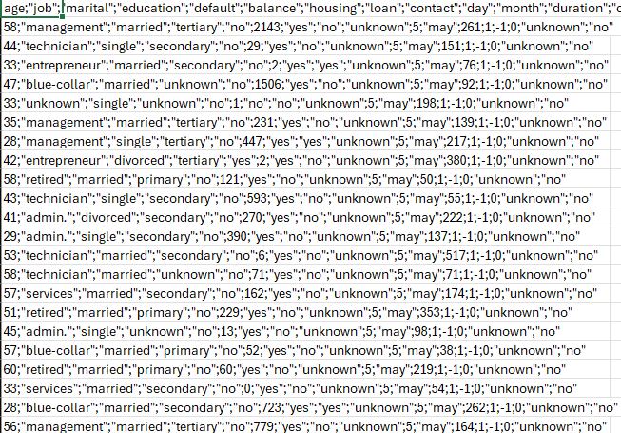
Dataset Attributes
The important attributes used in the dataset are:
Attribute | Description
age | Age of the customer
job | Type of job
marital | Marital status
education | Education level
default | Whether the customer has credit in default
balance | Average yearly balance
housing | Whether the customer has a housing loan
loan | Whether the customer has a personal loan
contact | Type of communication used
day | Day of the month when contact was made
month | Month when contact was made
duration | Duration of the last contact
campaign | Number of contacts during the current campaign
pdays | Number of days since the customer was previously contacted
previous | Number of previous contacts
poutcome | Result of the previous marketing campaign
y | Target variable indicating subscription

The input attributes were selected because they contain demographic, financial, communication, and campaign-related information that can be useful for understanding customer subscription behaviour.
Pseudocode
The overall pseudocode used for the project is:
START

Load the Bank Marketing dataset

Inspect rows, columns and data types

Check for missing values and duplicate records

Clean the dataset

Convert the target variable:
yes → 1
no → 0

Perform exploratory data analysis

Plot numerical distributions

Plot categorical frequencies

Check potential outliers

Calculate mean and variance

Calculate covariance and correlation

Calculate confidence interval

Separate input variables and target variable

Encode categorical variables

Scale numerical variables

Split data into training and testing sets

Train Logistic Regression model

Train Decision Tree model

Train kNN model

Calculate accuracy, precision, recall and F1-score

Display confusion matrices

Compare all classification models

Select the most suitable model

Select customer attributes for clustering

Standardize clustering variables

Apply K-Means clustering

Analyse customer clusters

Compare cluster subscription rates

Identify high-potential and low-response groups

Provide marketing recommendations

END

Data Preprocessing
The dataset was first loaded into Python using Pandas. Since the CSV file uses semicolons as separators, the dataset was read using sep=";".
After loading the data, I checked its shape, column names, data types, missing values, and target distribution.
There were no missing values in the dataset. I also checked for duplicate records, and the result was 0 duplicate rows. Therefore, no duplicate records had to be removed.
The target variable y was originally represented using yes and no. For machine learning, it was converted into numerical values:
yes → 1
no → 0
This makes it easier for the classification algorithms to work with the target variable.
Categorical variables were converted into numerical form using one-hot encoding during model preprocessing. Numerical variables were scaled using standardization.
Data Cleaning and Transformation
The first step in cleaning was checking whether any values were missing. All columns had zero missing values, so there was no need to fill or remove missing records.
I also checked for duplicate rows. The dataset contained no duplicate records.
The target variable was converted from text to numerical form. For the categorical input attributes, one-hot encoding was used. This converts categories such as job type, marital status, education, and contact type into numerical columns without assigning an artificial numerical order to them.
For numerical features, Standard Scaler was used. Scaling is particularly useful for kNN because it calculates distances between observations. Without scaling, variables with larger numerical ranges could have a greater influence on the distance calculation.
The cleaned dataset was then used for both statistical analysis and machine learning.
Exploratory Data Analysis
Exploratory Data Analysis was performed to understand the overall structure of the customer data.
The analysis included:
- Customer subscription distribution
- Age distribution
- Customer distribution by job
- Balance outlier analysis
- Correlation analysis
These graphs helped me understand the dataset before building the machine learning models.

Customer Subscription Distribution
The target variable shows how many customers subscribed and how many did not subscribe.
There were:
- 39,922 customers who did not subscribe
- 5,289 customers who subscribed
This shows that the dataset is imbalanced because the number of non-subscribers is much larger than the number of subscribers.
The subscription rate is approximately 11.70%, while around 88.30% of customers did not subscribe.
This imbalance is important when evaluating the classification models. Accuracy alone should not be used to judge the models because a model could obtain a high accuracy by mainly predicting the majority class.
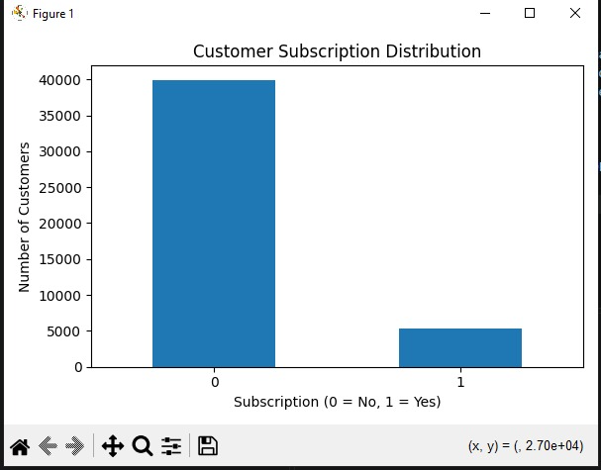
Age Distribution
The age distribution was plotted using a histogram. The average age of the customers in the dataset is approximately 40.94 years.
The histogram gives an idea about the age groups represented in the bank's customer base. Most customers are adults in the middle-age range, while relatively fewer customers are found at the extreme age ranges.
Understanding age distribution is useful because customer responses to banking products can vary across different age groups.
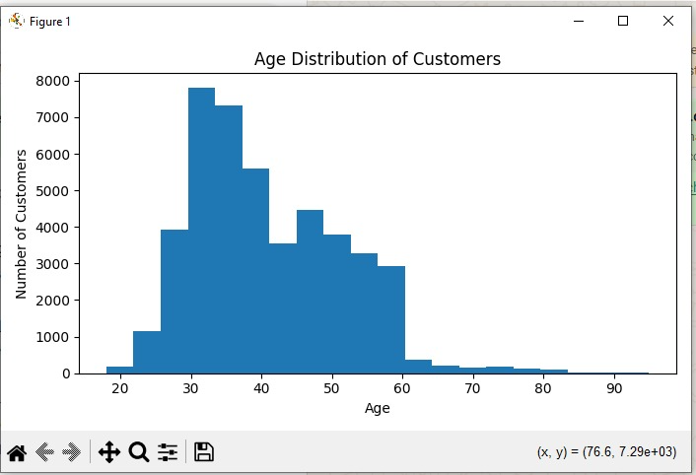 Customer Distribution by Job
The job attribute contains different categories such as management, technician, blue-collar, services, retired, entrepreneur, student, and others.
A bar graph was used to compare the number of customers belonging to different job categories.
This graph helps identify which professional groups make up a larger part of the customer base. The information can be useful when designing marketing messages for different customer groups.
PASTE GRAPH HERE: Customer Distribution by Job
Section 13 – Outlier Analysis
A boxplot was used to examine the distribution of customer balance.
The balance variable contains a wide range of values. Some customers have considerably higher balances than the majority of customers, which appear as extreme values in the boxplot.
These values were not automatically removed because a high bank balance is not necessarily an error. It can represent a genuine high-value customer. Removing such records without a valid reason could result in loss of useful information.
Therefore, the balance values were retained for the analysis.
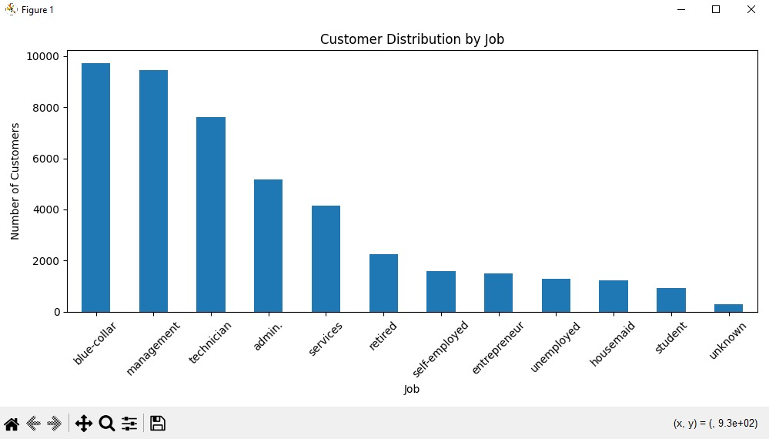 Subscriber and Non-Subscriber Comparison
The target variable was used to divide customers into two groups: subscribers and non-subscribers.
From the overall dataset, only 5,289 customers subscribed compared with 39,922 who did not.
One noticeable relationship is between the duration of the last contact and subscription behaviour. The correlation between duration and the target variable is approximately 0.3945, which is the strongest positive correlation among the selected numerical variables.
This suggests that customers with longer last-contact durations tended to have a higher subscription rate in this dataset.
However, this relationship should be interpreted carefully because the duration of a call is known after the call has taken place. Therefore, it is more useful for analysing the dataset and understanding campaign behaviour than for a prediction system that needs to decide whom to call before the conversation starts.

Descriptive Statistics
Descriptive statistics were calculated for four important numerical variables: age, balance, duration, and campaign.
The mean values were:
Variable | Mean
Age | 40.9362
Balance | 1362.2721
Duration | 258.1631
Campaign | 2.7638
The average customer age is approximately 40.94 years. The average balance is approximately 1362.27, while the average duration of the last contact is about 258.16 units as represented in the dataset. The average number of contacts during the current campaign is approximately 2.76.
Variance Analysis
Variance was calculated to understand how much the values of each numerical variable vary around their respective means.
The calculated variances were:
Variable | Variance
Age | 112.7581
Balance | 9,270,599
Duration | 66,320.5741
Campaign | 9.5977
The balance has a very large variance compared with age and campaign because customer balances have a much wider numerical range.
The duration variable also shows considerable variation, meaning that the length of customer contacts differs substantially between customers.
Covariance Analysis
Covariance was used to understand whether two numerical variables tend to increase or decrease together.
The covariance results were:
age balance duration campaign
age 112.758107 3161.476700 -12.711716 0.156601
balance 3161.476700 9270599.000 16905.750545 -137.513232
duration -12.711716 16905.750545 66320.574090 -67.471794
campaign 0.156601 -137.513232 -67.471794 9.597733
Covariance values depend on the scales of the variables, so they are not as easy to compare directly as correlation values. For example, balance and duration have a positive covariance, indicating that they tend to increase together to some extent.
Correlation Analysis
Correlation was calculated to measure the strength and direction of relationships between the numerical variables and the target.
The important correlation values with the target were:
Variable | Correlation with Subscription
Age | 0.0252
Balance | 0.0528
Duration | 0.3945
Campaign | -0.0732
The strongest relationship is between duration and subscription, with a correlation of approximately 0.3945.
Campaign has a weak negative correlation of approximately -0.0732. This indicates that a higher number of campaign contacts is slightly associated with a lower subscription outcome in this dataset.
Age and balance have only weak positive relationships with the target.
Correlation does not prove that one variable causes another. It only shows the degree to which the variables move together.
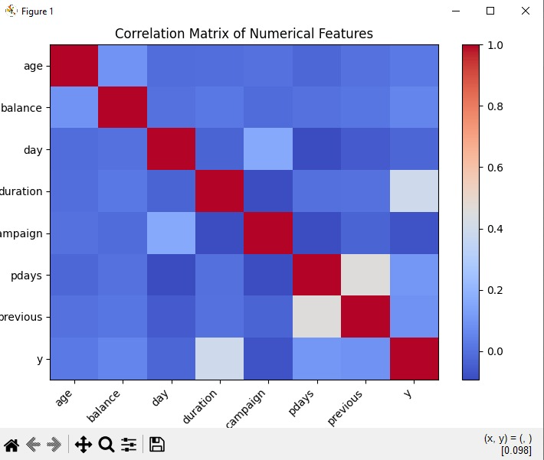 Statistical Inference
For statistical inference, I calculated a 95% confidence interval for the mean age of the customers.
The sample mean age was:
40.9362 years
The calculated 95% confidence interval was:
40.8383 to 41.0341 years
This means that, based on the sample and the confidence level used, the estimated population mean age falls within this interval.
The interval is relatively narrow because the dataset contains a large number of customer records.
 Train-Test Split
Before training the classification models, the dataset was divided into training and testing data.
I used:
- 80% training data
- 20% testing data
- random_state = 42
- Stratification based on the target variable
Stratification was used to maintain a similar proportion of subscribers and non-subscribers in both the training and testing datasets.
The categorical variables were one-hot encoded and numerical variables were standardized using a preprocessing pipeline.

Logistic Regression
Logistic Regression was used as one of the classification models.
The model predicts the probability that a customer belongs to the subscription class. In this project, the two classes are:
0 → Not Subscribed
1 → Subscribed
The Logistic Regression model achieved:
Metric | Result
Accuracy | 90.12%
Precision | 64.45%
Recall | 34.78%
F1-score | 45.18%
The accuracy is high, but the recall is considerably lower. This means the model correctly identifies many non-subscribers, but it misses a portion of customers who actually subscribed.
Decision Tree / CART
The second model used was a Decision Tree classifier.
A Decision Tree makes predictions by creating a series of decisions based on the input attributes. It is also relatively easy to understand because the decision process can be represented in the form of branches.
The Decision Tree achieved:
Metric | Result
Accuracy | 87.46%
Precision | 46.49%
Recall | 47.54%
F1-score | 47.01%
The Decision Tree had lower accuracy than Logistic Regression, but it achieved the highest recall and F1-score among the three models used in this project.
This makes the Decision Tree useful when the main objective is to identify more of the customers who actually subscribe.
k-Nearest Neighbours
The third classification algorithm was k-Nearest Neighbours, or kNN.
The kNN model classifies a customer based on the characteristics of nearby observations. Since kNN uses distance calculations, the numerical variables were standardized before training.
A value of k = 5 was used.
The results were:
Metric | Result
Accuracy | 89.62%
Precision | 59.90%
Recall | 34.03%
F1-score | 43.40%
The model performed reasonably well in terms of accuracy, but its recall and F1-score were lower than those of the Decision Tree.
Model Comparison
The three classification models were compared using the same testing dataset.
Model | Accuracy | Precision | Recall | F1-score
Logistic Regression | 90.12% | 64.45% | 34.78% | 45.18%
Decision Tree | 87.46% | 46.49% | 47.54% | 47.01%
kNN | 89.62% | 59.90% | 34.03% | 43.40%
Logistic Regression achieved the highest accuracy and precision. The Decision Tree achieved the highest recall and F1-score.
For this project, I consider Logistic Regression the best overall model based on accuracy and precision, with an accuracy of 90.12% and precision of 64.45%.
However, the Decision Tree would be a better choice if the bank's main priority were to identify as many actual subscribers as possible, because it has the highest recall of 47.54%.
Therefore, the best model depends on the business objective rather than only one metric.
PASTE GRAPH HERE: Classification Model Performance Comparison
Section 25 – Confusion Matrix Analysis
Confusion matrices were generated for all three models.
The Logistic Regression confusion matrix was:
[[7782 203]
[ 690 368]]
The Decision Tree confusion matrix was:
[[7406 579]
[ 555 503]]
The kNN confusion matrix was:
[[7744 241]
[ 698 360]]
For Logistic Regression, 7,782 non-subscribers were correctly classified and 368 subscribers were correctly identified. The model incorrectly classified 203 non-subscribers as subscribers and missed 690 actual subscribers.
The Decision Tree identified 503 actual subscribers, which is higher than Logistic Regression and kNN. This explains why its recall is higher.
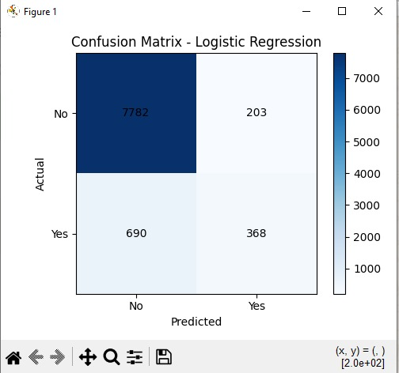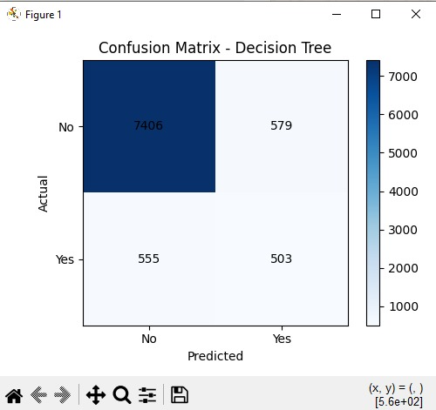
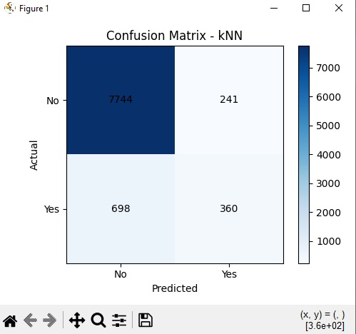
K-Means Customer Segmentation
After classification, K-Means clustering was applied to group customers based on selected numerical characteristics.
The following variables were used:
- Age
- Balance
- Duration
- Campaign
These variables represent demographic, financial, and campaign-related customer information.
Before applying K-Means, the variables were standardized so that differences in numerical scale would not dominate the clustering process.
Four clusters were used for the segmentation.
The resulting cluster sizes were:
Cluster | Number of Customers
Cluster 0 | 15,022
Cluster 1 | 24,434
Cluster 2 | 4,083
Cluster 3 | 1,672
The clusters were then examined based on their average characteristics and subscription rates.
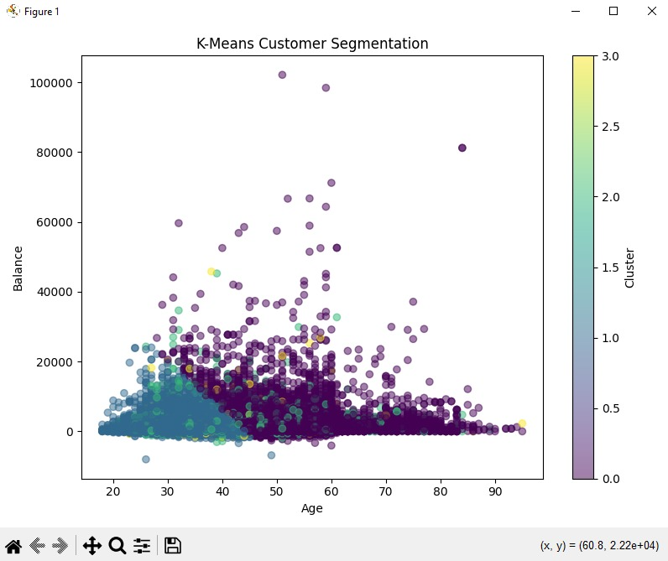 Cluster Characteristics
The characteristics of the four clusters were:
Cluster | Average Age | Average Balance | Average Duration | Average Campaign | Subscription Rate
Cluster 0 | 52.44 | 2038.35 | 198.37 | 2.40 | 9.46%
Cluster 1 | 34.09 | 948.10 | 198.13 | 2.23 | 7.97%
Cluster 2 | 39.91 | 1463.92 | 884.75 | 2.40 | 45.92%
Cluster 3 | 40.11 | 1092.37 | 142.56 | 14.71 | 2.69%
Cluster 0 contains relatively older customers with higher average balances. Its subscription rate is around 9.46%, which makes it a moderately promising group.
Cluster 1 is the largest group. It consists of relatively younger customers with lower average balances. Its subscription rate is approximately 7.97%.
Cluster 2 is the most interesting group because its average contact duration is much higher than the other groups and its subscription rate is approximately 45.92%. This makes it the highest-potential segment in the analysis.
Cluster 3 has a very high average campaign contact count of about 14.71, but its subscription rate is only 2.69%. This suggests that repeated contact is not necessarily producing better results for this group.
Section 28 – Customer Segmentation and Marketing Recommendations
Based on the cluster results, different strategies can be considered for each customer group.
Cluster 0 – Older and Higher-Balance Customers
These customers have a higher average balance and are older compared with the other clusters. The bank can use personalized offers and relationship-based communication for this segment.
Cluster 1 – Younger and Lower-Balance Customers
This is the largest segment, but its subscription rate is relatively low. Digital marketing, simple product explanations, and targeted online campaigns may be more suitable for this group.
Cluster 2 – High-Potential Customers
This group has the highest subscription rate at 45.92%. Customers in this segment should receive higher priority because they show strong engagement and a much better response rate.
The bank could focus on personalized offers, follow-up communication, and products that match their financial interests.
Cluster 3 – Low-Response Customers
This group has the lowest subscription rate at 2.69% despite having the highest average campaign contact count. Repeatedly contacting these customers may not be effective. The bank should consider changing the communication approach or reducing unnecessary repeated contacts.
Final Observations and SDG Relevance
The analysis showed that the Bank Marketing dataset contains a large majority of non-subscribing customers. The imbalance between subscribers and non-subscribers is an important factor when interpreting the classification results.
Among the three machine learning models, Logistic Regression achieved the highest accuracy at 90.12%. The Decision Tree achieved the highest recall and F1-score, showing that different models can be better depending on the evaluation metric.
The correlation analysis showed that duration had the strongest positive relationship with subscription among the selected numerical variables. However, this variable should be interpreted carefully for real-world prediction because the duration is known after customer contact.
The K-Means analysis divided customers into four groups. Cluster 2 was clearly the most promising segment because its subscription rate was approximately 45.92%. Cluster 3 was the lowest-response group, with a subscription rate of only 2.69%.
The project also relates to the Sustainable Development Goals mentioned in the assignment.
SDG 8 – Decent Work and Economic Growth: Data-driven banking decisions can help improve the efficiency of financial services and marketing activities.
SDG 9 – Industry, Innovation and Infrastructure: The project demonstrates the use of data science and machine learning to improve decision-making in a banking environment.
SDG 12 – Responsible Consumption and Production: Better customer targeting can reduce unnecessary marketing communication and help institutions use their resources more efficiently.
Conclusion and Individual Contribution
Conclusion
This project provided a complete data science workflow using a real-world bank marketing dataset. I started by inspecting and cleaning the data and then performed exploratory data analysis to understand customer characteristics.
Descriptive statistics helped me understand the distribution and relationships between numerical variables. I also calculated a 95% confidence interval for the mean customer age.
For classification, I implemented Logistic Regression, Decision Tree, and kNN. Logistic Regression produced the highest accuracy of 90.12%, while the Decision Tree achieved the highest recall and F1-score. This comparison showed why it is important to consider several evaluation metrics instead of relying only on accuracy.
K-Means clustering was then used to segment customers into four groups. Cluster 2 was the most promising segment, with a subscription rate of 45.92%. Cluster 3 had the lowest subscription rate, making it a low-response segment that may require a different marketing strategy.
Overall, the project showed how statistical analysis, machine learning, and customer segmentation can be combined to support better banking decisions. The results can help the bank focus its marketing efforts on customers who are more likely to respond while avoiding unnecessary repeated communication with low-response customers.
Individual Contribution Report
I worked on the different stages of the Bank Customer Subscription Prediction and Customer Segmentation System. My work included preparing the dataset, checking for missing values and duplicate records, converting the target variable into numerical form, and preparing categorical and numerical attributes for machine learning.
I performed the exploratory data analysis using Python and Pandas and created graphs for customer subscription distribution, age distribution, job categories, balance outliers, and correlation analysis. I also calculated descriptive statistics such as mean, variance, covariance, and correlation.
For the statistical inference part, I calculated the 95% confidence interval for the mean customer age. I then prepared the data for machine learning and implemented Logistic Regression, Decision Tree, and kNN models. I compared their accuracy, precision, recall, F1-score, and confusion matrices to understand their strengths and weaknesses.
I also worked on the K-Means clustering part of the project. I selected relevant numerical customer attributes, standardized them, applied clustering, and studied the characteristics and subscription rates of the resulting customer groups.
One of the main things I learned from this project was that a high accuracy value does not always mean that a classification model is performing equally well for every class. Looking at precision, recall, F1-score, and the confusion matrix gave a better understanding of the model's actual performance. I also learned how clustering can be used to find customer groups even when there is no predefined class for those groups.
The project helped me understand how the different parts of data science fit together, starting from raw data and ending with useful conclusions and business recommendations.

GITHUB LINK:
https://github.com/jithendrakumarreddy19-hash/DSA0402---FODS/tree/main/Bank_Customer_Assignment

